Differentiating for Learning in STEM Teaching

Exemplars of increasing the degree of challenge
(The four activities are based on work by Ben Law, a PGCE trainee at King’s College, London, 2016.)

Sorting statements
Sort the following statements about light and sound into the Thinking Organiser below:
  - Travel as waves
  - Detected by the ear
  - Can be absorbed
  - Can travel through a vacuum
  - Can be reflected
  - Travels well through solids
  - Detected by the eye
  - Can be refracted
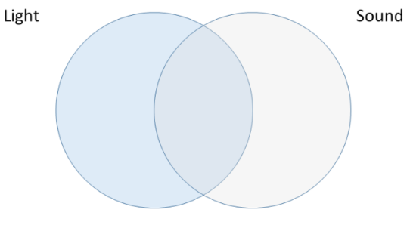

Correct words
Add the correct word to the paragraph using only Light or Sound.
_____ and _____ are both similar as they are both forms of energy and they exist and travel as waves. Three key properties that these have are the amplitude, frequency and wavelength. A _____ wave travels as a transverse wave, this means that the oscillations are at right angles to the direction of travel. A _____ wave can only travel through matter as it needs particles to vibrate. The _____ wave travels as a longitudinal wave with the particles vibrating in the direction the wave travels. A _____ wave can travel through a vacuum, however it cannot travel through opaque objects. _____ waves travel faster than _____ waves. Both ______ and _____ waves interact with different materials; they can be absorbed, reflected, refracted or transmitted.

True or false?
STATEMENT | TRUE? | FALSE?
When light and sound travel through different materials, the speed of the waves change
Light travels faster than sound
Sound waves can be seen on a screen if detected by a periscope
Both sound and light can be blocked by certain materials
You can hear sound in a vacuum like in outer space
Rewrite any of the statements that you think are false so they become a true statement.

Compare and contrast
Question or Statement | LIGHT | SOUND
What type of wave?
How are they detected by humans?
Changing the intensity leads to a change in …..
Changing the frequency leads to a change in …..
Type of surface that reflects these waves
Reflected waves are called .....
Through what do they travel fastest?
Speed of travel in air?
Frequencies below visible and audible range are called .....
Frequencies above visible and audible range are called .....
Complete the columns for light and sound for each of the questions or statements.

